**Nifty 50 Analysis for the Year 2023: Insights and Trends**



**What is NIFTY 50?** The NIFTY 50, often referred to simply as the Nifty, is the flagship index of the National Stock Exchange of India (NSE). It comprises the top 50 companies listed on the NSE, representing various sectors of the Indian economy. The Nifty 50 index serves as a benchmark for the Indian equity market, providing investors with a broad-based measure of the performance of the Indian stock market. Companies included in the Nifty 50 index are selected based on factors such as market capitalization, liquidity, and trading volume. The index is widely tracked by investors, traders, and financial analysts as an indicator of overall market sentiment and trends in the Indian stock market.

We utilized **yfinance** to gather data for Nifty 50 and all 50 constituent companies. This approach allowed us to access comprehensive historical stock data for the year 2023, including key metrics such as open, high, low, and close prices, as well as trading volume, for each company listed in the index.

**Exploratory Data Analytics**

How Nifty 50 prices varied this year ??

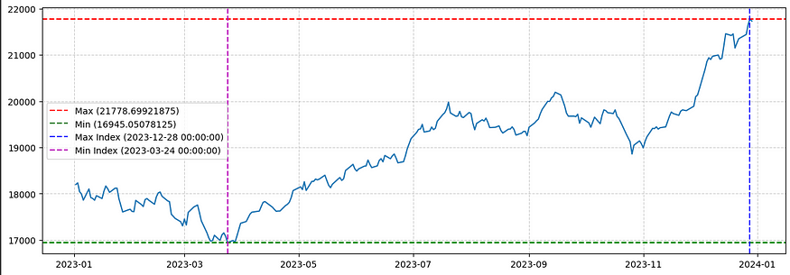

As shown in the figure it can be inferred that the Nifty 50 was at its all-time high on 28th December with a value of Rs. 21778.69921875 and it was at its all-time low on 24th March with a value of Rs. 16945.05078125. There can be different understandings of the fact that why the market was all-time low at the end the financial year. One of the main reasons can be the portfolio adjustments of these companies, adoption of new tax planning and release of corporate performance report for the companies.

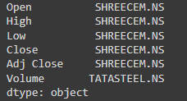

Stocks with Maximum Value

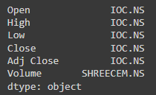

Stocks with Minimum Value

But how was the distribution of volume??

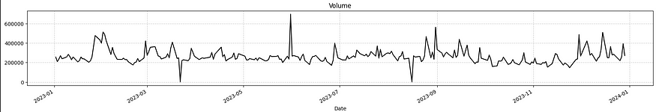

Hmmm!! The volume traded doesn’t have a significant change while the close price have shown an upward trend. It implies that there is buying interest, and investors/traders are willing to pay higher prices for the asset. In this case, since the volume hasn’t changed significantly, it might suggest that the upward price trend is not supported by a surge in trading activity.



Do you want to know which stocks gave the highest return on investment this year??

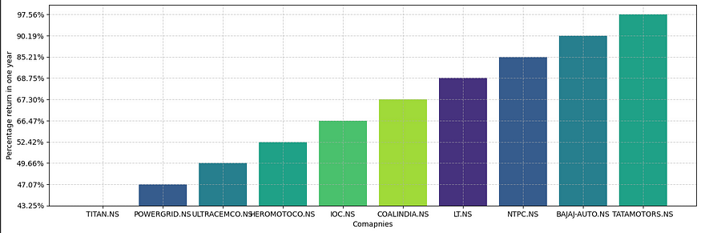

But do we need ROI only ??? Or anything else to measure of stocks. Let’s have a look.

Performance

The performance of a stock reflects its price movement and financial health over time. It encompasses factors such as price changes, total return, and fundamental metrics like earnings and revenue growth. Understanding stock performance is crucial for making informed investment decisions, managing risk, and evaluating investment strategies. By analyzing past performance and comparing to benchmarks, investors can assess a stock’s potential and its relative strength within the market.



Volatility

Volatility in stock markets denotes the degree of fluctuation in stock prices over time, representing both risk and opportunity for investors. High volatility implies greater price swings and potential returns, but also heightened risk, while low volatility suggests stability but potentially lower returns. Assessing volatility aids investors in understanding the risk profile of individual stocks and constructing diversified portfolios to mitigate risk. Moreover, volatility serves as an indicator of market sentiment, reflecting investor confidence or apprehension. By factoring volatility into investment decisions, investors can tailor their strategies to market conditions and pursue their financial goals with greater precision and resilience.



Do you want to know what is the relationship between all the features like Open, High , Low , Close , Adjacent Close and Volume ?? Let’s find out using Pearson correlation.

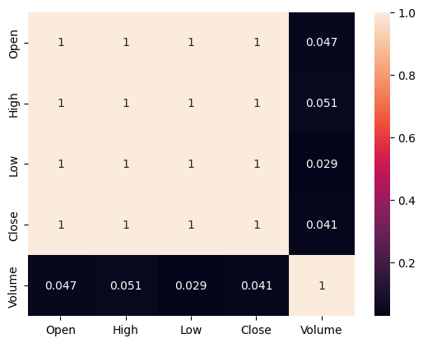

Heat Map

It seems all the features are highly correlated except Volume. Which is not varying at all even if all other prices are varying. For reference 1 indicates it is positively related, 0 indicates no relation at all and -1 indicates a negative relation.

Now. Let’s Move to our next segment which is Sector wise analysis of these stocks. So , we divided these stocks according to the type of industry from which they belong and tried to have a deep look on it.

Before investing let’s find out the average prices of stocks in each sector.

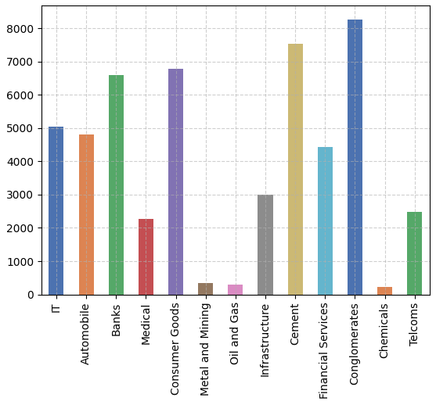

Average Price Vs Industry

Notably, conglomerates and cement stocks emerge with the highest average prices, indicating potentially strong market demand and investor confidence in these sectors. Conversely, industries such as oil and gas, along with chemicals, exhibit lower average prices, suggesting possible challenges or subdued investor sentiment within these sectors. This disparity in average prices across industries highlights varying market perceptions, potential growth prospects, and underlying economic factors influencing investor behavior. Further analysis could delve into the drivers behind these price disparities, such as sector-specific trends, regulatory environments, or global economic conditions, to glean deeper insights into market dynamics and inform investment decisions effectively.

Which sector really performed well ??

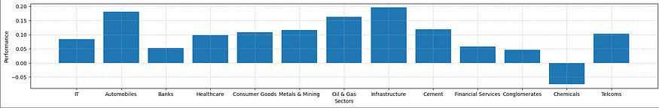

The robust performance of infrastructure and automobile industries may stem from increased government spending on infrastructure projects and growing consumer demand for vehicles, signaling potential growth opportunities and investor confidence in these sectors. Conversely, the negative performance of the chemicals industry may reflect challenges such as regulatory hurdles, supply chain disruptions, or declining demand, prompting investors to reassess their positions within the sector.

And which sector was most volatile??

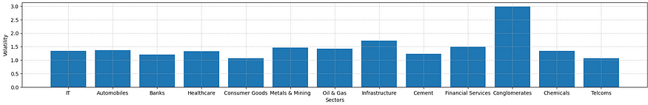

The observation that conglomerates exhibit the highest volatility, potentially due to the presence of stocks like Adani Enterprises, known for significant price swings following release of Hindenburg Report, offers valuable insights. On the other hand, FMCG and telecom sectors display the least volatility, indicating relatively stable price movements. This disparity suggests differing risk profiles across sectors, with conglomerates presenting higher risk due to individual stock dynamics, while FMCG and telecom sectors provide investors with more predictable performance.

Relationship between these sectors?

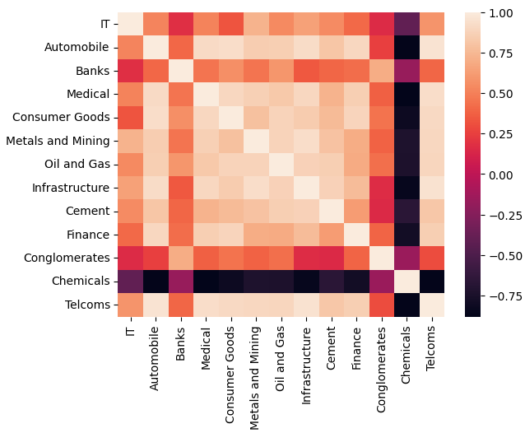

This observation underscores the interconnectedness of these industries and their pivotal role in driving the economy forward. Together, they form the backbone of economic activity, each contributing its unique strengths and dynamics to the overall landscape. By understanding the intricate relationships between these sectors, we gain deeper insights into the mechanisms that power our economy, facilitating informed decision-making and strategic planning for sustainable growth and prosperity.

**Technical Analysis**

Now, Let’s dive deeper into the world of quant and try to explore some useful Technical Indicators used by Hedge-Funds and try to produce insights from it.

What are Technical Indicators and why do we need them ?

Technical indicators serve as invaluable tools for hedge funds, enabling them to identify trading opportunities, time market entries and exits, manage risk, conduct quantitative analysis, and gauge market sentiment. By analyzing historical price movements and interpreting signals generated by indicators such as moving averages, RSI, and Bollinger Bands, hedge fund managers can make informed decisions about when to buy or sell securities, optimize position sizes, and capitalize on market trends. These indicators also play a crucial role in quantitative trading strategies, providing inputs for mathematical models that exploit patterns and relationships in historical data. Ultimately, technical indicators empower hedge funds to navigate dynamic market conditions, enhance trading strategies, and achieve their investment objectives with greater precision and confidence.

Candle Sticks

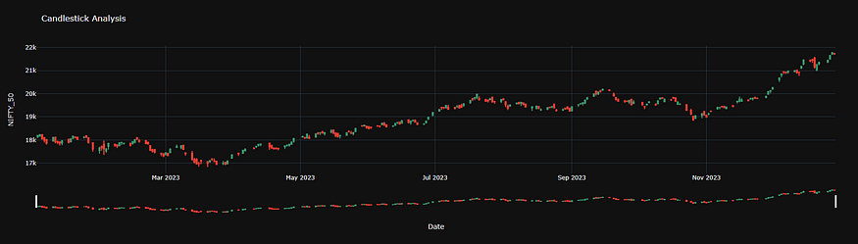

Candlestick charts visually represent price movement in financial markets. Each candle has a body reflecting the opening and closing prices and wicks showing the high and low. A bullish candle is typically green, indicating a price increase, while a bearish one is red, signaling a decrease. Long bodies suggest significant movement, while short ones indicate less change. Doji candles reveal market indecision, and hammers show potential reversals. Engulfing patterns, where one candle covers the range of the previous one, may indicate trend changes. Traders use these patterns alongside other analyses for informed decision-making.

OHLC Charts

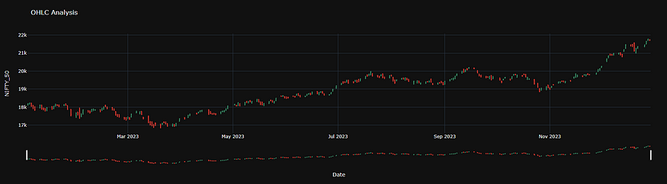

OHLC (Open, High, Low, Close) charts are financial charts displaying the opening, high, low, and closing prices of an asset for a given time period. Each bar represents a single period, with a vertical line extending from the lowest to the highest price, and horizontal lines indicating the opening (left) and closing (right) prices. A rising bar suggests a price increase (bullish), while a falling bar signals a decrease (bearish). Patterns and trends in OHLC charts offer insights into market sentiment, allowing traders to make informed decisions. Combining OHLC charts with technical analysis tools enhances their utility in financial analysis.

Gauge Indicators

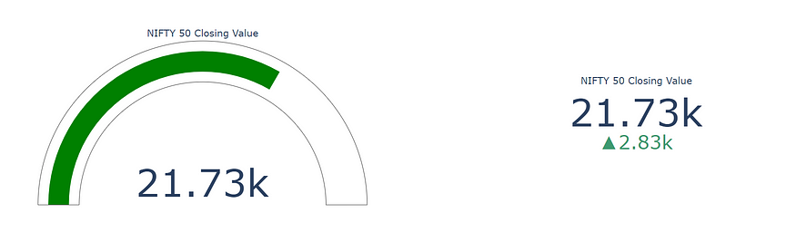

You may be familiar with this, if you ever watched the CNBC. What does it really means? It typically includes determining the percentage or fraction of the value range corresponding to the current metric value and transforming this calculation to match the physical layout of the gauge scale. This is now showing the results on the last day of year 2023 with a very good indication. Which shows that it was a very good year for our economy.

Relative Strength Index

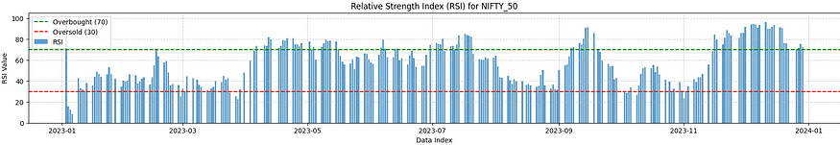

RSI is a popular indicator used by investors to gauge the momentum of a stock’s price movements. It measures the magnitude of recent price changes to determine whether a stock is potentially overbought or oversold. RSI values range from 0 to 100, with readings above 70 typically indicating that a stock is overbought and may be due for a price decrease, while readings below 30 suggest that a stock is oversold and may be poised for a price increase. Traders often use the RSI to identify potential buying or selling opportunities and to confirm trends in stock prices.

Average Turn Ratio

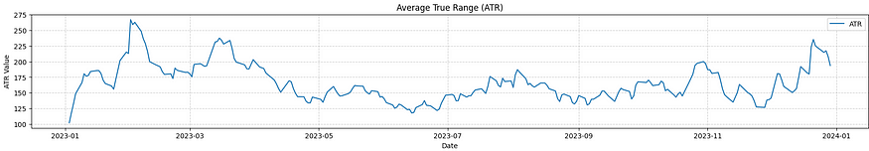

ATR is a tool used by investors to measure the volatility of a stock or market. It calculates the average of a stock’s true range, which is the difference between the high and low prices over a specified period. A higher ATR indicates greater volatility, while a lower ATR suggests less volatility. Traders use the ATR to assess the potential risk and reward of a trade, as well as to set stop-loss orders and determine position sizes based on market volatility.

ATR Bands

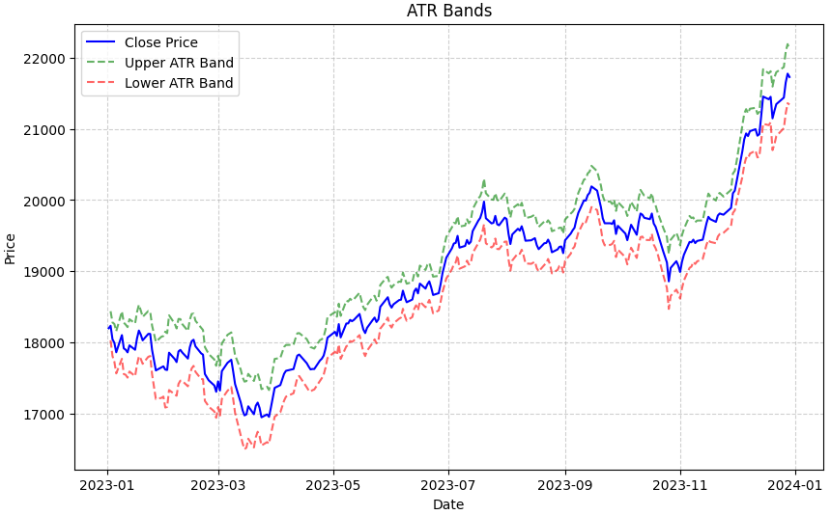

ATR bands are typically plotted above and below a stock’s price chart, with the bands expanding and contracting based on the level of volatility. These bands serve as dynamic support and resistance levels, helping traders identify potential entry and exit points, as well as gauge the strength of trends. When prices trade near the upper band, it may suggest overbought conditions, while prices near the lower band may indicate oversold conditions. Traders often use ATR bands in conjunction with other technical indicators to make informed trading decisions and manage risk effectively.

**Is it Sunshine or Rain for the Markets?**

Feeling like a weather forecaster for the stock market? Dive into the mysterious world of the Ichimoku cloud! This chart isn’t about fluffy white shapes, but about shady areas that can give clues about a Nifty 50 company’s price movements.

Imagine the cloud as a mood ring for the market. An upward cloud slope suggests sunshine — a potentially bullish trend where prices might find support. A cloud dipping down? That’s a storm brewing — a possible bearish trend with resistance ahead.

The thickness of the cloud matters too! A thick cloud means the market might be extra volatile, with prices bouncing around like a coin toss. A thin cloud suggests things are calmer, with prices consolidating (like taking a breather).

Support and Resistance Level

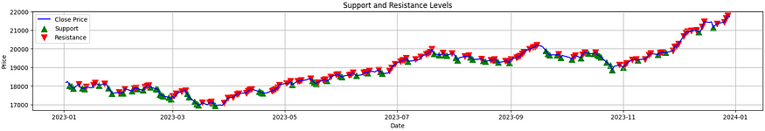

Support levels are areas where the price tends to find support as it falls, preventing it from declining further. Resistance levels, on the other hand, are areas where the price tends to encounter selling pressure as it rises, preventing it from advancing further. These levels are often identified based on historical price data, such as previous highs and lows, and are considered key reference points for traders in determining entry and exit points for trades. When a stock’s price breaks above a resistance level, it may indicate a bullish trend, while a break below a support level may signal a bearish trend. Traders use support and resistance levels to set price targets, place stop-loss orders, and gauge the strength of market trends.

Fibonacci Retracement

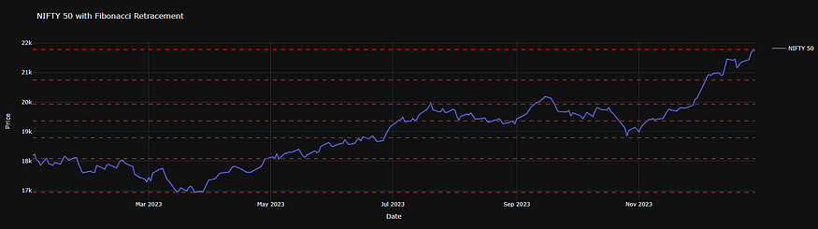

These ratios, derived from the Fibonacci sequence, include key levels such as 23.6%, 38.2%, 50%, 61.8%, and 100%. Traders draw Fibonacci retracement levels on a price chart by connecting a significant high to a significant low, or vice versa, and then dividing the vertical distance by the Fibonacci ratios. The resulting retracement levels represent potential areas where the price may retrace or reverse its direction. These levels often coincide with support and resistance levels, providing traders with key reference points for identifying entry and exit points for trades. Fibonacci retracement levels are widely used in technical analysis to help traders anticipate price movements and make more informed trading decisions.

MACD

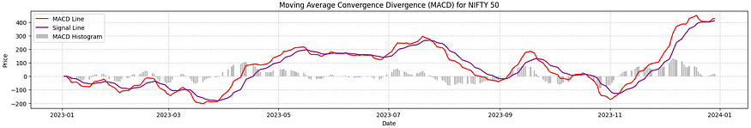

MACD, or Moving Average Convergence Divergence, is a popular technical analysis tool used by traders and investors to identify potential trends and momentum shifts in a stock or market. It consists of two main components: the MACD line and the signal line. The MACD line is calculated by subtracting the longer-term exponential moving average (EMA) from the shorter-term EMA. The signal line is a moving average of the MACD line itself.

Traders use the MACD to identify bullish and bearish signals. When the MACD line crosses above the signal line, it is considered a bullish signal, indicating potential upward momentum. Conversely, when the MACD line crosses below the signal line, it is considered a bearish signal, indicating potential downward momentum. Additionally, the distance between the MACD line and the signal line, known as the histogram, can provide further insight into the strength of the trend.

Overall, the MACD is a versatile tool that helps traders identify trends, momentum, and potential entry and exit points for trades.

Bollinger Bands

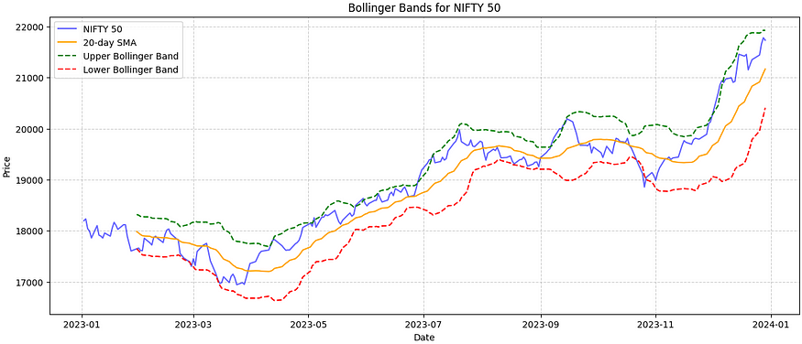

Bollinger Bands, a popular technical analysis tool, consist of three bands: a middle band representing the simple moving average of a stock’s price, and upper and lower bands calculated by adding and subtracting a multiple of the standard deviation from the middle band. These bands serve as dynamic support and resistance levels, expanding and contracting based on market volatility. Traders use Bollinger Bands to identify potential buy and sell signals: when the price approaches the upper band, it may indicate overbought conditions, while movement towards the lower band may suggest oversold conditions. Breakouts from the bands can signal the beginning of new trends.

Do you know what is seasonal decomposition?

Seasonal decomposition is a statistical technique used to analyze time series data by separating it into different components: trend, seasonal, and residual. The primary use of seasonal decomposition is to identify and quantify seasonal patterns or fluctuations in the data, allowing analysts to understand and account for them when making forecasts or analyzing trends.

By decomposing the time series into its constituent components, seasonal decomposition helps isolate the underlying patterns and trends from the noise or random fluctuations in the data. This enables analysts to better understand the underlying structure of the data and make more accurate forecasts by accounting for seasonal effects.

Seasonal decomposition is commonly used in various fields, including economics, finance, and environmental science, where time series data often exhibit repetitive patterns or seasonal variations. It provides valuable insights into the seasonal dynamics of the data and helps analysts make informed decisions based on a deeper understanding of its underlying patterns and trends.

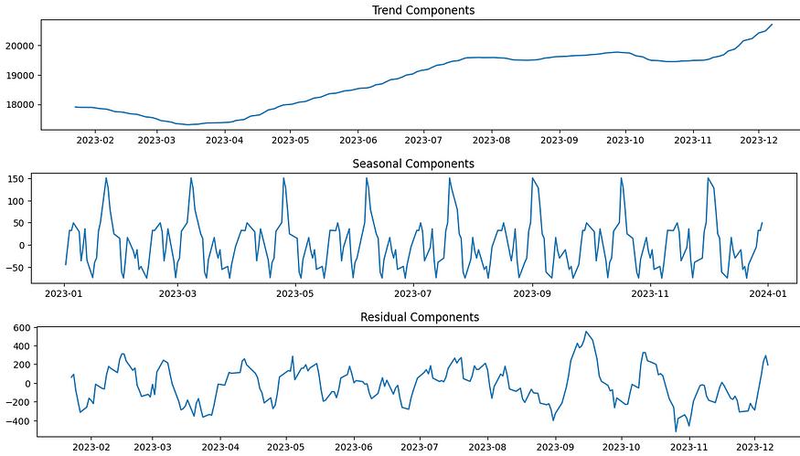

1. Trend Component: Represents the long-term movement or direction of the data, capturing overall growth or decline trends over extended periods.  
   2. Seasonal Component: Reflects repetitive patterns or fluctuations in the data occurring at regular intervals, such as daily, weekly, or monthly cycles, influenced by seasonal factors like weather or holidays.  
   3. Residual Component: Represents random or unpredictable fluctuations in the data that cannot be explained by the trend or seasonal patterns, capturing variability or noise remaining after removing these effects.

**Forecasting**

Initiating our base line forecasting using XGBoost Regressor. The XGBoost model for stock forecasting exhibits a significant discrepancy between training and validation/test performances. For the training data, the model achieved a MAE of 18.51, RMSE of 25.23, R² of 0.9994, and accuracy of 100.00%, indicating a perfect fit. However, on the validation data, the model's performance drastically declined, with a MAE of 337.06, RMSE of 390.91, R² of -1.7804, and accuracy still at 100.00%. Similarly, the test data showed a MAE of 554.55, RMSE of 629.63, R² of -3.0669, and an accuracy of 96.77%. Despite the high training accuracy, the substantial errors and negative R² values on validation and test data indicate severe overfitting. This means the model fits the training data extremely well but fails to generalize to unseen data, evidenced by the drop in accuracy to 96.77% on the test set. These results highlight the need for better generalization techniques or model tuning to achieve reliable and robust stock forecasting.

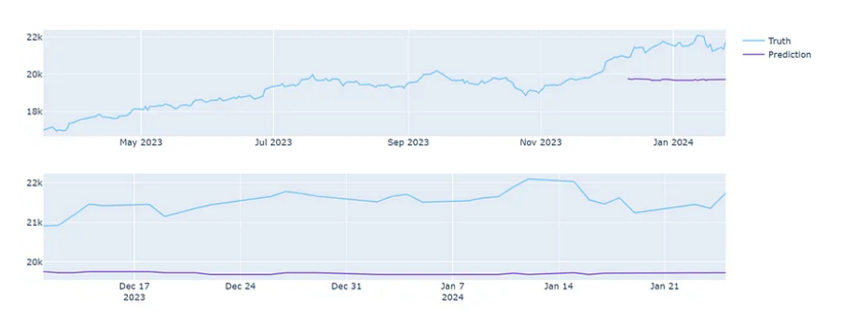

Now, let’s forecast. We are using a different kind of approach to deal with its forecasting. We are using a technique called stacking in which we will put the predictions of two RNNs called LSTM and GRU into a linear regression to get a blended output. Which was surpassing the results when we implemented any of those techniques one at a time.

Results on our training and testing data

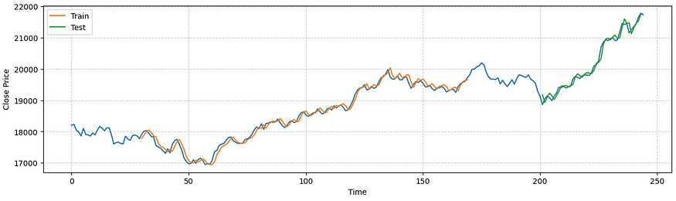

Now. let’s predict for the entire month of January from the data we have , around 248 data points.

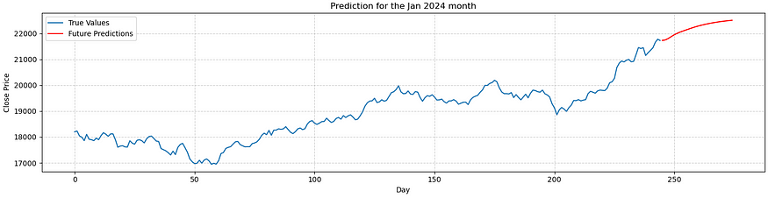

You may be wondering about what exactly happened in the market compared to our model’s prediction.

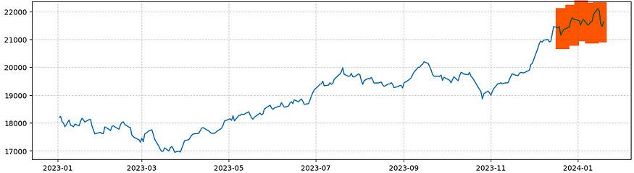

Pretty accurate right!!! At least the trend was exactly same.

note: RMSE: 127.9871199581492

In conclusion, our exploration of NIFTY 50 and its associated trends has provided illuminating insights into the broader stock market landscape. Through detailed analysis of sector-wise performance, volatility patterns, and price fluctuations, we’ve uncovered valuable information regarding market dynamics and investor behavior. These insights serve as crucial guides for investors, enabling informed decision-making and strategic positioning within the ever-evolving financial markets. By leveraging these findings, stakeholders can better navigate uncertainties, capitalize on emerging opportunities, and steer their investment strategies towards success.